P23G/P23GW
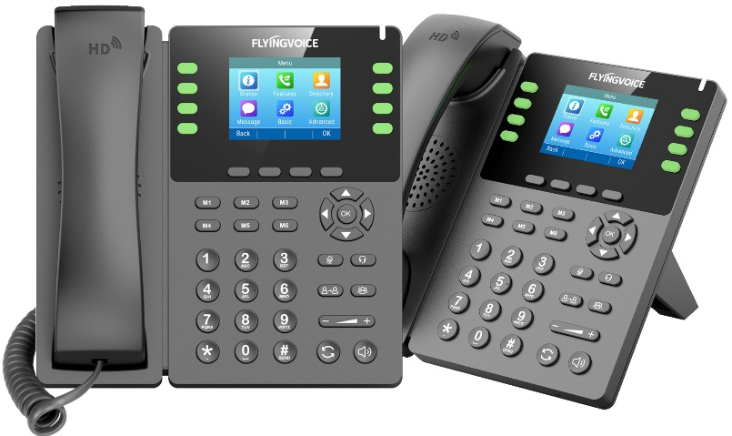
Feature-rich business IP Phone
P23G/P23GW multi-functional color screen Wi-Fi phone, equipped with 2.8-inch large IPS color screen with backlight, continuation of the original stylish design, giving you a comfortable visual collaboration experience. The built-in Gigabit Ethernet ports, PoE and USB2.0 port of P23 series support access USB flash drive, EHS10 adapter, Bluetooth dongle and other device access to meet the office needs in different scenarios. Moreover, P23GW has built-in 2.4G & 5GHz dual-band Wi-Fi module to achieve high-speed data communication and provide you with the more efficient co-working services.
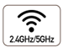
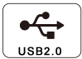




8 Lines

PoE
HD

Key Features and Benefits


HD voice, Quality calls
P23 series supports Opus wideband codec with advanced echo cancellation technology and intelligent noise cancellation technology to provide users with HD voice for better quality voice calls.


Dual-band Wi-Fi and Convenient networking
Flyingvoice P23 series support 2.4G & 5G Hz WiFi and PoE module to meet the office needs of enterprise wired/wireless network access.


USB expansion, Rich Application scenarios
P23 series integrates USB2.0 interface, supports EHS10 adapter, Bluetooth and 5G Wi-Fi dongle, realizes USB flash recording, DECT and Bluetooth wireless headset to access calls, providing users with more wireless office services.


Simple installation and Easy Deployment
Flyingvoice P23 series can be easily deployed and managed by online platforms such as FACS and FRPS and auto-provisioning modes FTP/TFTP/HTTP/HTTPS/TR069, greatly saving on operation and maintenance time.
Flyingvoice Network Technology Co., Ltd
sales@flyingvoice.com
www.flyingvoice.com

- 2.8“ 320×240px backlight LCD screen
- 8 SIP accounts
- Built-in 2.4G & 5G Hz Wi-Fi (P23GW)
- Opus codec support
- Dual Gigabit Ethernet ports
- USB 2.0 port for USB recording
- Support PoE
- Dect headset, RJ9 headset
- 6-Way conferencing
- Stand with 2 adjustable angles
- Wall mountable

P23G/P23GW Specifications
Phone Features
LCD Screen | > 2.8" 320 x 240px color screen with backlight  > 16-bit depth color
Function Keys | > 12 Function Keys: M1, M2, M3, M4, M5, M6, mute, headset, transfer, redial, hands-free, conference  > 8 Line keys, 4 Soft Keys, 5 Navigate Keys, Volume+/-
SIP Accounts | > 8 SIP accounts
Wi-Fi | > 2.4GHz & 5GHz Wi-Fi (P23G: 2.4G Hz Wi-Fi)
USB Port | > USB call recording through USB flash drive  > Wireless Headset Adapter EHS10  > Bluetooth earphone through BT50
Ethernet Port | > 2*10/100/1000M（adaptive)  > Support PoE
Other Ports | > 1 x Extension port (Flyingvoice P2EXP Color screen Expansion Module)  > 1 x Handset port  > 1 x RJ9 Headset port  - Wire-controlled RJ9 headset through HP200
Call Features
Basic function | > Call hold, Mute, DND, Redial, Auto answer, One-touch speed dial, Hotline, SMS, Call forward, Call waiting, Call transfer (attended/blind), Paging, Voice mail, BLF, Anonymous call, Anonymous call rejection, Message waiting indicator (MWI), Hot desking
Direct IP Call | > Supported
Phone book | > 2000 records; Phonebook search/import/export; XML/LDAP remote phonebook; Black list
Call history | > 800 records; Call history: All/missed/dialed/received/transfer
Conference Call | > 6-way conference, Network conference
Audio Features
HD Voice | > HD handset, HD speaker
Audio Codec | > G.722, Opus, AMR-WB(Optional), G.711WB(Optional), G.711(A/u), iLBC, G.729A/B, G.723, G.726, AMR-NB(Optional)
DTMF | > In-band, RFC 2833, SIP info
Network
Network Safety | > SIP Related Features:  - SIP v1 (RFC2543), v2 (RFC3261), NAT Traversal by STUN  - Random SIP Port and R port  - SIP link mode: Proxy mode and peer-to-peer SIP link mode  - Call server redundancy supported  > Network Features:  - Static IP and DHCP, IPv4 /IPv6, Dual stack IPv4/IPv6, ARP/RARP, DNS A/DNS SRV/DNS NAPTR  - LLDP/CDP/DHCP VLAN; IEEE802.1X; OpenVPN; DSCP, 802.1p QoS  > Time and Date synchronization: SNTP, PBX, DHCP  > Transport Feature: UDP/TCP/TLS(1.3); RTP/RTCP/SRTP

Configuration & Maintenance
Auto-provision | > TR069（TR104/TR106）  > FTP/TFTP/HTTP/HTTPS for Auto Provisioning  > Cloud device management: FACS  > Cloud device management: FRPS  > DHCP Option66
Configuration | > Supports web configuration  > Factory reset, reboot  > Packet capture, system log
Others
Physical Features | > New Stand, Wall mountable  > AC/DC Adapter, AC Input: 100~240V, 50~60Hz  > DC Output: 5V, 2A  > Power consumption (PSU): 1.6~3.0W  > Power consumption (PoE): 1.7W~3.3W  > Relative humidity: 10%~90% (No Condensing)  - Storage temperature: -20~ 70°C  - Operation temperature: 0~45°C  > Dimension (W x D x H): 190mm × 188.5mm × 41mm
Package Content
Details | Packing List:  > Flyingvoice P23G/P23GW IP Phone, Power adapter (optional)  > Handset with handset cord, Ethernet cable, Stand  > Quick Start Guide  Size:  > Qty/CTN: 10 PCS, N.W/CTN: 8.31 kg, G.W/CTN: 10.66 kg  > Giftbox size: 270mm × 195mm × 78mm  > Carton size: 440mm × 410mm × 290mm
Certification & Compatibility
Certificated by |     
Compatible with |   
* For more Compatibility information, refer to https://www.flyingvoice.cn/partners/technology-partners.html
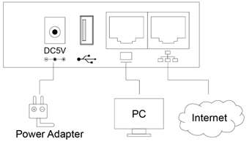
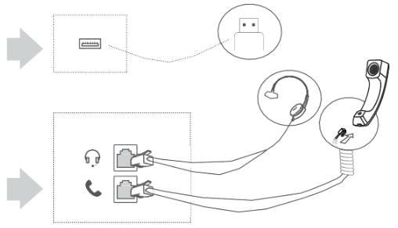
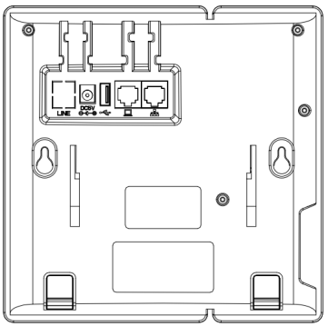
www.flyingvoice.com
sales@flyingvoice.com
Flyingvoice Network Technology Co., Ltd.

About Flyingvoice
Flyingvoice is a leading manufacturer of VoIP phones, VoIP adapters and VoIP routers, which are widely used throughout the world and highly praised
by international carriers, ITSP, ISP and company users.

Driven by ongoing innovation of VoWLAN, Flyingvoice is committed to making easier VoIP products by enabling the enterprise network and united
communication. Our people are continuously improving our products and expanding product applications tailored to clients’ requirements, which make
you collaborate securely, effectively and efficiently – anytime & anywhere.

Copyright
Copyright © Flyingvoice Network Technology Co., Ltd. All rights reserved. No parts of this publication may be reproduced or transmit- ted in any form or by any means, electronic or mechanical, photocopying, recording, or otherwise, for any purpose, without the express written permission of Flyingvoice Network Technology Co., Ltd.

Technical Support
Visit www.flyingvoice.com for product documents and FAQ, or contact Flyingvoice by email at support@flyingvoice.com. We’ll get you the help you need.


Flyingvoice Network Technology Co., Ltd. Website: www.flyingvoice.com
Add: 1801-1802, Building 1, Chongwen Park, Nanshan Zhiyuan,
Nanshan District, Shenzhen, China
Copyright© Flyingvoice Network Technology Co., Ltd. All Rights Reserved

Flyingvoice Network Technology Co., Ltd
sales@flyingvoice.com
www.flyingvoice.com

